1. **Click Create API**

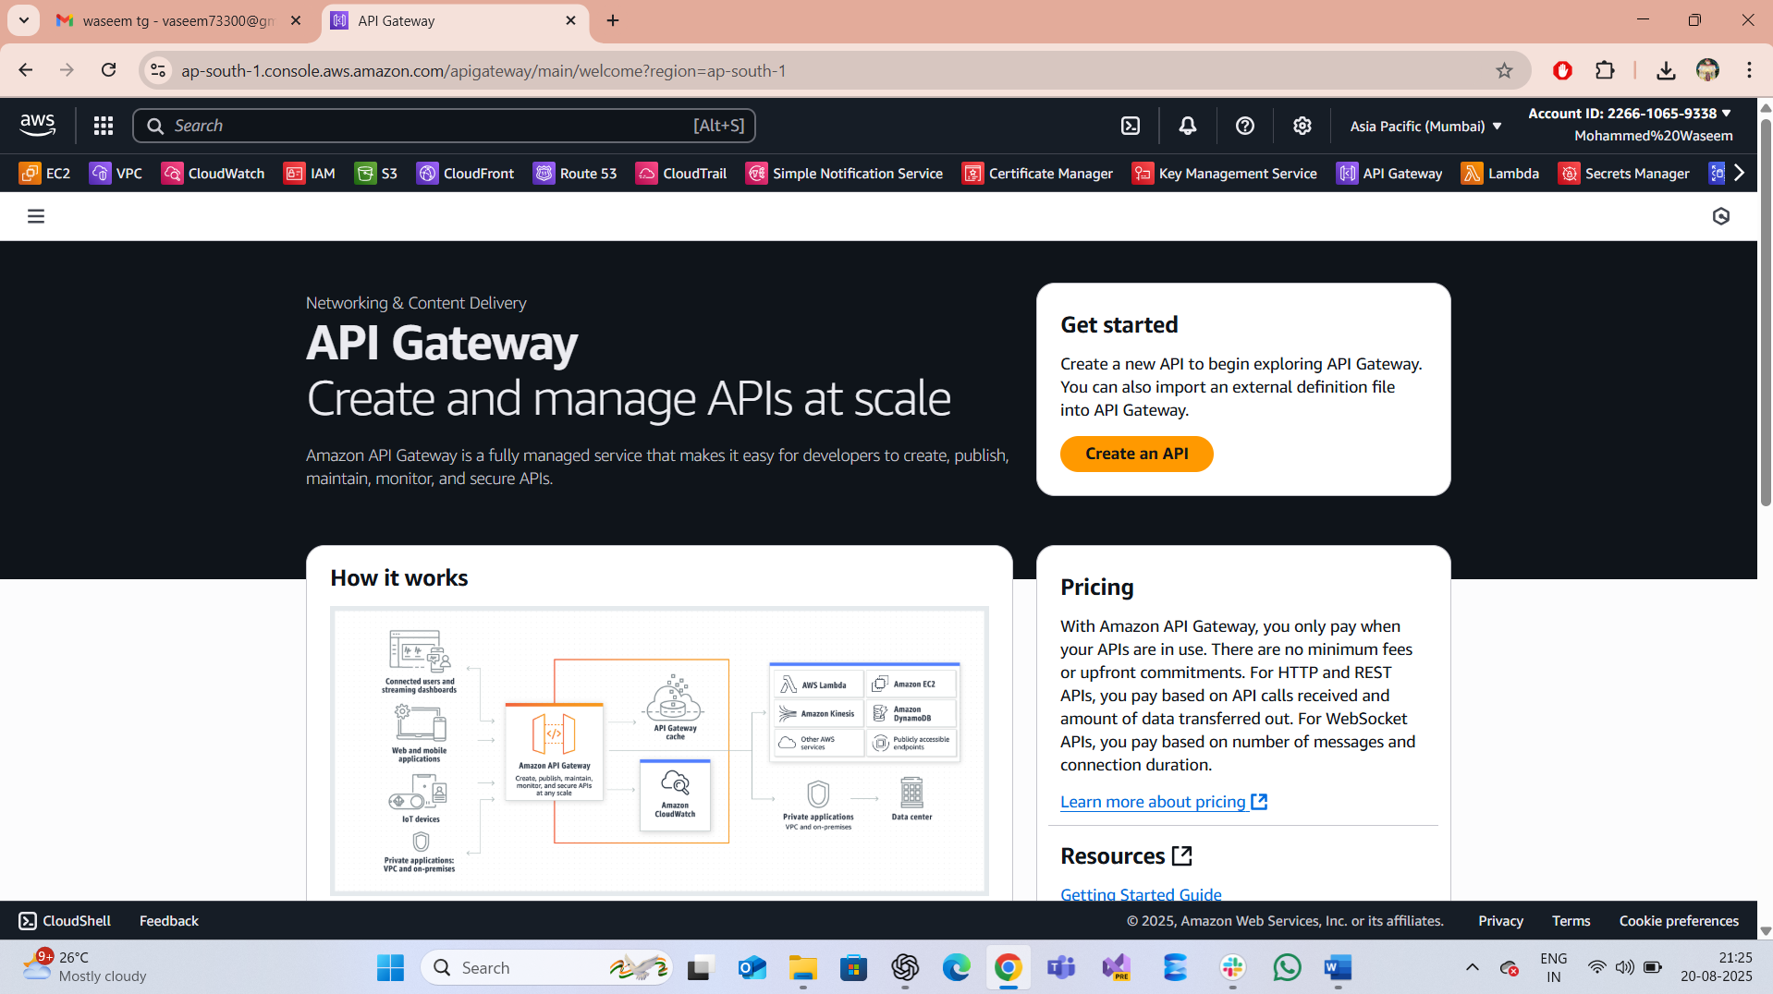

1. **Choose API**   
   Select the API type you need:  
   HTTP API (simpler, low-cost).  
   REST API (more features like usage plans, API keys).  
   WebSocket API (real-time communication)

1. **Configure API Details**API Name: Enter a name.  
   Description: Optional.  
   Endpoint Type: (for REST API):  
   Regional (default).  
   Edge-optimized (global clients).  
   Private (inside your VPC).

1. **Create Routes or Resources**

For HTTP APIs:  
Define routes like /users, /orders.  
Assign HTTP methods (GET, POST, etc.).

1. **Create a stage (e.g., dev, test, prod).**Deploy your API to the selected stage.  
   This generates a public invoke URL for your API.

1. **Created the integration API and need to select the ANY in dropdown**

